Week2 : Program Design

Example :
Question: Create a simple program that calculates the area of a rectangle.

Step-by-step Example

Define the Problem
create a program that calculates the area of a rectangle.

Input: length and breadth of the rectangle.
Output : area of the rectangle.
Process: calculate the area of the rectangle ( Area = Length * breadth)

Input | Processing | Output
Length,  Breadth | Calculate Area = Length *  Width | Area

Outline the Solution

  - Input the length of the rectangle
  - Input the breadth of the rectangle
  - Calculate the area of the rectangle, Area = Length * breadth
  - Output Area
**You may want to imaging how the program will look like, it might help you to design your solution
Enter the length of the rectangle: 3 Enter the width of the rectangle: 4 Area of the rectangle is 12

Algorithm – Using Pseudocode
START
DISPLAY “Enter the length of the rectangle:” GET length
DISPLAY “Enter the breadth of the rectangle:” GET width
CALCULATE
Area = length * breadth
DISPLAY “Area of the rectangle is “, Area
END

- Flowchart

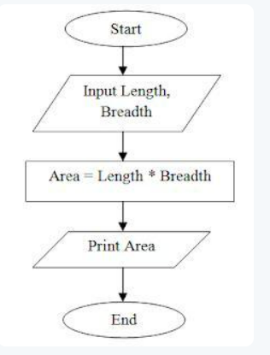

Part A: Complete the following sequence structure tutorials using Pseudocode and flowchart.

  - Calculate employee income tax based on the following formula: Tax = 0.25 * (monthly income * 11 – number of kids * 450)
Your program will display the name of the employee and amount of tax on the screen.
  - Program that reads two numbers and multiplies them together and print out the product.
  - Program that will calculate area and circumference of circle. Get input from user and display the area and circumference of circle.

Part B: Complete the following conditional and repetition structure tutorials using Pseudocode and flowchart

- Design an algorithm to check if the year enter is a leap year or not a leap year.

- Design an algorithm that will prompt the user for the price of an article and a pricing code. Your program is then to calculate a discount rate according to the pricing code and print to the screen the original price of the article, the discount amount, and the new discounted price. Calculate the pricing code and accompanying discount amount as follows:

Pricing code | Discount rate
H | 50%
F | 40%
T | 33%
Q | 25%
Z | 0%

- Design an algorithm that asks the user to enter a number and prints a countdown from
the number entered by the user to zero. Hint: Using While loop.

Part C: Homework : Submit the following work into Moodle under Lab1 HomeworkFolder .

Complete the following tutorials using pseudocode and flowchart.

  - Calculate and display the Celsius equivalent of the Fahrenheit temperature inputted by the user using the formula:

Fahrenheit = Celsius * 9/5 + 32

  - Design an algorithm to calculate the BMI (body mass index) of user based on their weight and height. BMI’s Formula: (weight / (height (m) x height (m))).

Determine the category of user’s BMI as follows:

underweight | BMI less than 18.5
Normal weight | BMI between 18.5 and 24.9
overweight | BMI between 25 and 29.9
obese | BMI 30 and above

  - Construct an algorithmic solution for producing a multiplication table.

  - Design an algorithm that will print a series of number in a range of 100. The iteration will be i+10.

